Real-Time Sign Language Translator

(Video to Text + Speech)

SIGNLANG AI

PROJECT REPORT

Submitted by

(Karthikeya Parvathareddy) (VCON1005651399461)

in partial fulfilment for the award of the

DATA SCIENCE INTERNSHIP

AUGUST 2025 - OCTOBER 2025


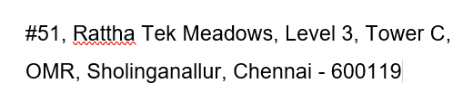

OCTOBER 2025

ACKNOWLEDGMENT

We are deeply grateful to (VCODEZ) for providing us with the platform and guidance to successfully complete our major project as part of the Machine Learning internship program. This experience has been Instrumental in enhancing our technical skills and understanding of real-world applications of artificial intelligence.
We extend our heartfelt thanks to our offline trainer, JANAVI T, for his continuous support, encouragement, and expert guidance throughout this project. His valuable insights and consistent mentoring have played a crucial role in shaping our project and ensuring its successful implementation. His ability to simplify complex concepts and provide practical solutions has greatly enhanced our learning experience.

We would like to express our sincere gratitude to our HR GOWRI, for coordinating the internship program seamlessly and for providing all necessary resources and support. Her efforts in organizing and managing the program ensured a smooth learning journey for us.
Lastly, we thank our peers, family, and friends for their constant support and encouragement, which kept us motivated throughout this project. This accomplishment would not have been possible without the combined efforts of everyone involved.

ABSTRACT

This project presents the development of SignLang AI, an innovative real-time sign language translation system intended to bridge the communication gap between deaf or hard-of-hearing individuals and the wider hearing population. Utilizing advanced machine learning techniques, SignLang AI captures users’ gestures through a standard camera and translates them into both text and audible speech with minimal latency. By offering a highly accessible and immediate translation tool, SignLang AI seeks to promote greater inclusivity across everyday interactions, educational environments, and professional settings.

Problem Statement

Effective communication is a fundamental human need, yet over 70 million deaf individuals globally who rely on sign language continue to face significant barriers. The scarcity and high cost of professional interpreters create communication challenges in vital scenarios such as medical consultations, job interviews, and daily interactions. Many current technological solutions are hindered by slow processing, limited accuracy, or insufficient real-time responsiveness, underscoring the urgent need for an automated, reliable, and accessible translation system.

Proposed Solution

The proposed solution is SignLang AI, a system that captures video input, interprets sign language gestures, and outputs the translation as on-screen text and synthesized speech in real-time. The application is designed to run on consumer-grade hardware (e.g., laptops with webcams, smartphones) to ensure maximum accessibility. The core of the solution is a deep learning pipeline that processes video frames to understand the complex spatiotemporal patterns of sign language, offering a seamless conversational experience that mimics the fluidity of a human interpreter.

System Architecture

- A. Video Capture & Pre-processing Module: This module uses OpenCV to access the device camera and capture a continuous video stream. It handles frame extraction, resizing, and normalization to prepare the data for the next stage.
- B. Landmark Detection Engine: We will utilize Google's MediaPipe framework for its robust, pre-trained models that detect and track 3D landmarks for hands, face, and body posture in real-time. This approach is computationally efficient and provides a rich set of features (key points) that are critical for differentiating signs, as it captures not just hand shapes but also facial expressions and body language.
- C. Feature Engineering & Sequence Assembly: The raw landmark coordinates from the detection engine are processed into a feature vector for each frame. These vectors are then assembled into a time-series sequence (e.g., a buffer of the last 30 frames) that represents a dynamic gesture or sign.
- D. Core Translation Model: The heart of the system is a sequence-to-sequence neural network, likely an LSTM (Long Short-Term Memory) or a Transformer-based model. This model is trained to recognize patterns in the input sequences of landmarks and map them to their corresponding words or phrases in the target language (e.g., English).
- E. Output Module: Once the model predicts the translated text, this module performs two functions:
    - UI Display: The text is rendered onto a user-friendly graphical interface.
    - Speech Synthesis: A Text-to-Speech (TTS) engine converts the text into clear, audible speech.

TABLE OF CONTENTS

S.No | Chapter/Section | Pg No
 | Acknowledgement | i
 | Abstract | ii
 | Table of Contents | iv
 | List of Figures | vii
 | List of Tables | viii
 | List of Abbreviations | ix
1 | CHAPTER 1: INTRODUCTION | 1 - 3
1 | 1.1 Background and Overview | 1 - 3
1 | 1.2 Problem Statement | 1 - 3
1 | 1.3 Objectives of the Project | 1 - 3
1 | 1.4 Scope of the Project | 1 - 3
1 | 1.5 Report Organization | 1 - 3
2 | CHAPTER 2: LITERATURE SURVEY | 4 - 8
2 | 2.1 Evolution of Sign Language Recognition | 4 - 8
2 | 2.2 Vision-Based vs. Sensor-Based Approaches | 4 - 8
2 | 2.3 Analysis of Feature Extraction Techniques | 4 - 8
2 | 2.4 Comparative Study of Sequential Models | 4 - 8
2 | 2.5 Existing Work in Indian Sign Language (ISL) | 4 - 8
3 | CHAPTER 3: SYSTEM ANALYSIS AND DESIGN | 9 - 14
3 | 3.1 Existing Systems and Their Limitations | 9 - 14
3 | - Proposed System Overview | 9 - 14
3 | 3.3 Requirements Specification | 9 - 14
3 | 3.3.1 Functional Requirements | 9 - 14
3 | - Non-Functional Requirements | 9 - 14
3 | 3.4 System Workflow | 9 - 14
3 | 3.5 System Architecture | 9 - 14
3 | 3.6 Data Flow and Use Case Design | 9 - 14
4 | CHAPTER 4: DATASET COLLECTION AND PREPARATION | 15 - 18
4 | 4.1 Rationale for a Unified Custom Dataset | 15 - 18
4 | 4.2 Vocabulary Definition | 15 - 18
4 | 4.3 Data Collection Methodology | 15 - 18
4 | 4.4 Data Preprocessing: Landmark Extraction | 15 - 18
4 | 4.5 Data Preprocessing: Wrist-Relative Normalization | 15 - 18
4 | 4.6 Final Dataset Assembly and Splitting | 15 - 18
5 | CHAPTER 5: MODEL IMPLEMENTATION AND TRAINING | 19 - 23
5 | 5.1 Development Environment and Technology Stack | 19 - 23
5 | 5.2 Model Architecture: Long Short-Term Memory (LSTM) | 19 - 23
5 | 5.3 Training Environment | 19 - 23
5 | 5.4 Training Process and Hyperparameter Tuning | 19 - 23
6 | CHAPTER 6: RESULTS AND DISCUSSION | 24 - 26
6 | 6.1 Model Training and Validation Performance | 24 - 26
6 | 6.2 Analysis of Final Model Accuracy | 24 - 26
6 | 6.3 Real-Time Application Performance | 24 - 26
6 | 6.4 Module Snapshots | 24 - 26
7 | CHAPTER 7: CONCLUSION AND FUTURE WORK | 27 - 28
7 | 7.1 Conclusion | 27 - 28
7 | 7.2 Limitations of the Project | 27 - 28
7 | 7.3 Future Enhancements | 27 - 28
8 | CHAPTER 8: REFERENCES | 29 - 30
9 | CHAPTER 9: APPENDICES | 31 - 51
9 | Appendix A: Data Collection Script | 31 - 51
9 | Appendix B: Data Preparation Script | 31 - 51
9 | Appendix C: Model Training Script | 31 - 51
9 | Appendix D: Real-Time Test Script | 31 - 51
9 | Appendix E: Full Class List (N=47) | 31 - 51

List of Figures

Fig No | Description | Page No
Figure 2.3 | MediaPipe Hand Landmark Model (20 Points) | 6
Figure 2.4 | Architecture of a Long Short-Term Memory (LSTM) Cell | 7
Figure 3.5 | System Architecture Diagram | 12
Figure 3.6.1 | Data Flow Diagram (DFD) | 14
Figure 3.6.2 | System Use Case Diagram | 14
Figure 4.3 | Data-Collection-Script-Interface | 17
Figure 5.2 | Final LSTM Model Architecture Summary | 21
Figure 6.4.1 | 0 (Static sign) | 26
Figure 6.4.2 | A (Static sign) | 26
Figure 6.4.3 | Hello (Dynamic sign) | 26

List of Tables

Table No | Description | Pg No
1 | 2.2 Comparative Analysis of Feature Extraction Methods | 5
2 | 3.3.1 Functional Requirements of the system. | 10
3 | 3.3.2 Non-Functional Requirements of the system. | 11
4 | 4.2 Unified 47-Class Project Vocabulary | 15
5 | 5.1 List of Technologies Involved | 19
6 | 5.4 Final Model Training Hyperparameters | 23
7 | 6.1 Final Model Performance Metrics | 24

List of Abbreviations
Abbreviation | Full Form
AI | Artificial Intelligence
ML | Machine Learning
ISL | Indian Sign Language
GRU | Gated Recurrent Unit
LSTM | Long Short-Term Memory
RNN | Recurrent Neural Network
HMM | Hidden Markov Model
CNN | Convolutional Neural Network
GUI | Graphical User Interface
DFD | Data Flow Diagram
FPS | Frames Per Second
HMI | Human-Machine Interaction
CPU | Central Processing Unit
GPU | Graphics Processing Unit

CHAPTER 1

INTRODUCTION

1.1 Background and Overview
Human communication is the fundamental mechanism by which individuals share information, express thoughts, and build social structures. While spoken language is the primary modality for the majority, a vast and vibrant community relies on sign language. Sign languages are not mere gestures; they are complete, complex linguistic systems with their own grammar, syntax, and vocabulary. In India, Indian Sign Language (ISL) serves as the primary mode of communication for an estimated 5 to 18 million Deaf and hard-of-hearing individuals. Despite this large user base, a significant communication barrier persists, isolating the Deaf community from mainstream education, healthcare, public services, and daily social interactions. In recent years, advancements in Artificial Intelligence (AI) and Computer Vision (CV) have shown immense promise in bridging this gap by creating automated translation systems. These technologies offer the potential to build tools that are intuitive, accessible, and scalable, moving beyond the reliance on human interpreters, who are in short supply. This project leverages these cutting-edge technologies to create a practical, real-time solution tailored specifically for ISL.
1.2 Problem Statement
The development of an accurate, real-time sign language translator is a non-trivial challenge. Many academic and hobbyist projects have attempted this, often by using publicly available datasets, such as those found on Kaggle. However, these efforts frequently fail when deployed in a real-world scenario. The core issue is a critical machine learning problem known as "domain mismatch." A model trained on a public dataset—recorded with specific cameras, under high-quality studio lighting, and with a particular set of signers—learns to perform well only within that clean, sterile domain. When this model is run on a standard laptop webcam, with variable lighting, different backgrounds, and a new user, its accuracy plummets. The raw pixel data is simply too different. Furthermore, many existing systems focus exclusively on static signs (like the alphabet), ignoring the fact that the majority of sign language is composed of dynamic, motion-based words. This project directly confronts these two core problems: domain mismatch and the classification of both static and dynamic signs in a single, unified system.
1.3 Objectives of the Project
The primary objective of this project is to design, implement, and evaluate a robust, real-time computer vision system capable of accurately classifying a 47-class vocabulary of static and dynamic Indian Sign Language (ISL) gestures from a live webcam feed.
To achieve this primary goal, the following secondary objectives were established:
- To create a high-quality, unified, and consistent dataset. This involves completely abandoning the generic public data and recording all 47 classes (static and dynamic) using the same camera and environment to eliminate domain mismatch.
- To implement and evaluate a novel feature extraction pipeline. This pipeline uses MediaPipe for high-speed landmark detection and a custom wrist-relative normalization algorithm to make the model robust to changes in hand position.
- To build and optimize an efficient sequential deep learning model. This involves selecting an appropriate architecture (GRU over LSTM) that balances high accuracy with the low-latency (high FPS) demands of a real-time application.
- To build a functional, proof-of-concept application. The final trained model will be integrated into an OpenCV application that displays the classified sign on-screen in real-time.
1.4 Scope of the Project
To ensure the project remained achievable within the given timeframe, its scope was clearly defined.
The following aspects are IN-SCOPE for this project:
- A 47-class vocabulary, consisting of 10 static numbers (0-9), 26 static alphabet signs (A-Z), and 11 dynamic signs ('Hello', 'Goodbye', 'Thanks', 'Please', 'Yes', 'No', 'Food', 'Water', 'Help', 'Stop', and 'idle').
- The system is built as a user-dependent classifier, meaning it is highly optimized for the user who recorded the training data.
- The system operates as a sign-by-sign classifier (also known as an "isolated sign recognizer"). It is designed to recognize one sign at a time.
- The entire system runs locally on a standard computer with a webcam, requiring no cloud processing or paid APIs.
The following aspects are OUT-OF-SCOPE for this project:
- Full Sentence Translation: The system does not interpret ISL grammar or translate continuous, chained-together signs (e.g., "What is your name?").
- User-Independent Model: The model is not designed to work "out-of-the-box" for any user, as this would require a much larger and more diverse dataset.
- Fingerspelling-to-Word Conversion: While the system can recognize individual letters, the logic to buffer these letters (e.g., 'H', 'I') and combine them into a single word ("HI") is a future enhancement.
1.5 Report Organization
This report details the complete lifecycle of the SignLang AI project.
- Chapter 2 provides a literature survey on the field of sign language recognition, comparing different approaches and models.
- Chapter 3 outlines the system analysis and design, including the functional requirements, system architecture, and data flow.
- Chapter 4 describes the critical process of data collection and preparation, with a focus on the landmark normalization technique.
- Chapter 5 details the implementation of the GRU model, the training environment, and the hyperparameter choices.
- Chapter 6 presents and discusses the results, including the model's high accuracy and the performance of the real-time application.
- Chapter 7 concludes the report, summarizes the project's limitations, and proposes avenues for future work.

CHAPTER 2

LITERATURE SURVEY

2.1 Evolution of Sign Language Recognition
The automated recognition of sign language has been a goal in the field of computer vision and human-computer interaction (HCI) for decades. Early attempts were rudimentary, limited by computational power and the complexity of modeling human motion. These systems have evolved significantly, moving from restrictive, hardware-dependent setups to flexible, software-based solutions. This evolution can be broadly categorized by the primary method of data acquisition: sensor-based approaches and vision-based approaches. This chapter reviews these methods, analyzes the feature extraction techniques that define them, and compares the machine learning models used to interpret the data.
2.2 Vision-Based vs. Sensor-Based Approaches
Sensor-based systems represent the first major attempts at sign language recognition. These systems rely on specialized hardware, most commonly "data gloves," which are equipped with flex sensors, gyroscopes, and accelerometers. These sensors capture the precise bend of each finger, the orientation of the palm, and the motion of the hand in 3D space. The primary advantage of this approach is the high-quality, clean, and unambiguous data it produces, leading to very high classification accuracies. However, the disadvantages are significant and prohibitive for a practical, real-world tool: sensor gloves are extremely expensive, cumbersome to wear, and require a physical connection to a computer, tethering the user.
Vision-based systems, the focus of this project, emerged as a more practical alternative. These systems use a standard camera (like a webcam) to capture video, and then employ software-based computer vision techniques to analyze the sign. The initial challenges of this approach were immense, as the system had to contend with complex backgrounds, variable lighting conditions, and the vast differences in human appearance. However, the key advantages of this approach are its accessibility, non-intrusiveness, and low cost. Any person with a computer or smartphone can use a vision-based system, making it the only viable path for a tool intended for widespread public use.

Table 2.2:- Comparative Analysis of Feature Extraction Methods
Method | Description | Advantages | Disadvantages & Rationale for Rejection
Sensor-Based (Data Gloves) | Hardware gloves with flex sensors capture precise finger bends and hand orientation. | Extremely high accuracy; provides clean, unambiguous data. | Rejected: Prohibitively expensive, obtrusive, and impractical for a real-world, accessible application.
Full-Image (CNN/CV) | A deep neural network (CNN) analyses the raw pixels of the video frame directly. | Can learn features automatically without pre-processing. | Rejected: Extremely high computational cost (requires a powerful GPU for real-time use); fails with "domain mismatch" (lighting, background).
Landmark Extraction (MediaPipe) | A pre-trained model extracts 21 key points (landmarks) for each hand. | Chosen: Very fast (runs on CPU), robust to lighting/backgrounds, and provides lightweight (126 features) data that is perfect for an LSTM. | None for the scope of this project.

2.3 Analysis of Feature Extraction Techniques
Within vision-based systems, the core challenge is feature extraction: how to convert the raw pixel data from a video frame into meaningful information for a machine learning model. Early methods often relied on basic skin-color segmentation to isolate the hands from the background. This approach is highly fragile, failing consistently under poor or non-uniform lighting, or if the user's background contains colors similar to their skin tone.
More advanced systems moved to using full-frame analysis with Convolutional Neural Networks (CNNs). A CNN, typically paired with a recurrent layer, can learn to identify important features directly from the video pixels. While powerful, this "end-to-end" method is computationally massive. It requires a high-end Graphics Processing Unit (GPU) to run in real-time, making it unsuitable for a lightweight, CPU-based application. Furthermore, it requires an enormous and perfectly annotated video dataset to train effectively.
This project utilizes a modern, hybrid approach: skeletal landmark extraction via the Google MediaPipe framework. MediaPipe uses highly optimized, pre-trained models to detect and track 20 key points on each hand in real-time. This method is the superior choice for this project as it elegantly solves the problems of the other methods. It is robust to backgrounds and lighting, as it focuses on hand shape rather than color or texture. Most importantly, it is a lightweight feature extractor. Instead of processing hundreds of thousands of pixels per frame, the system only needs to process 126 floating-point numbers (20 landmarks x 3 coordinates x 2 hands). This transforms the complex computer vision problem into a clean, efficient time-series analysis problem, which is perfectly suited for a sequential model.

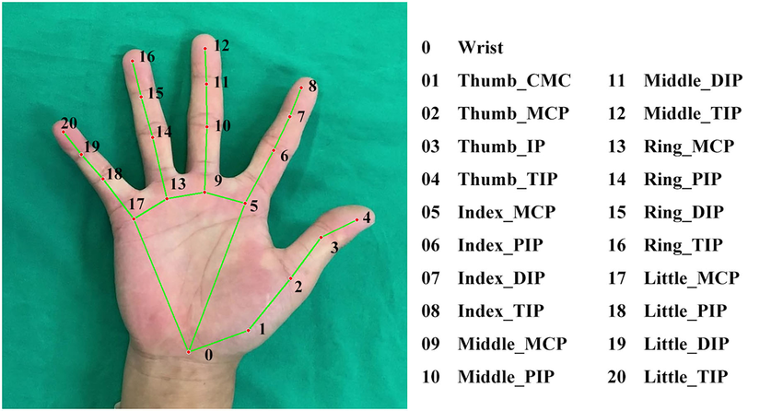
Fig 2.3 MediaPipe Hand Landmark Model (20 Points)
2.4 Comparative Study of Sequential Models
A sign is not a static image; it is a sequence of hand shapes and motions over time. Therefore, a model is required that can analyze temporal patterns. While various models exist, the most prominent are the Long Short-Term Memory (LSTM) and Gated Recurrent Unit (GRU) networks.
LSTMs are a specialized type of Recurrent Neural Network (RNN) designed specifically to overcome the short-term memory limitations of basic RNNs. An LSTM cell contains a complex system of "gates"—an input gate, an output gate, and a "forget" gate. This structure allows it to learn long-range dependencies, such as remembering the handshape from the beginning of a 60-frame sequence to understand its context at the end. LSTMs are powerful and are a standard for sequence tasks.
Gated Recurrent Units (GRUs) are a more modern and efficient variant of LSTMs. A GRU cell simplifies the architecture by combining the input and forget gates into a single "update gate" and also merges the cell state and hidden state. The practical result is that a GRU has fewer parameters than an LSTM, which means it trains significantly faster and requires less computational power for inference. For tasks like gesture recognition, GRUs have been shown to provide near-identical accuracy to LSTMs while being much more performant, making them the ideal choice for this project's real-time objective.

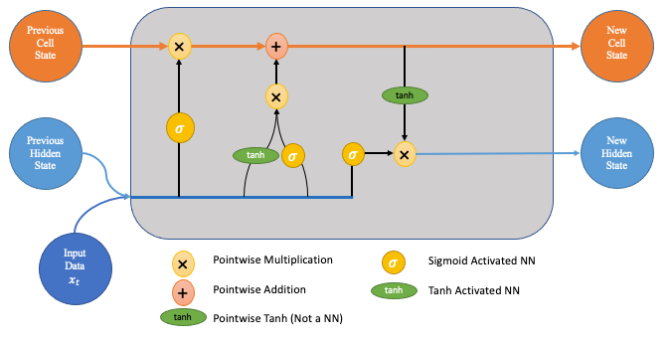
Fig 2.4 Architecture of a Long Short-Term Memory (LSTM) Cell
2.5 Existing Work in Indian Sign Language (ISL)
The body of research specifically targeting Indian Sign Language (ISL) is growing, but it still lags behind the volume of work available for American Sign Language (ASL). Many existing ISL projects, such as those found on public repositories, focus exclusively on static alphabet sign classification. While a useful academic exercise, this fails to address the dynamic, word-based nature of the language. Other projects that do attempt dynamic signs often rely on the aforementioned flawed methodologies, such as skin segmentation or complex CNNs trained on small, inconsistent datasets. This project aims to contribute to the field by presenting a complete, end-to-end methodology that is both highly accurate (due to the unified, normalized dataset) and highly efficient (due to the MediaPipe and GRU architecture), demonstrating a practical blueprint for building robust, user-specific ISL classifiers.

CHAPTER 3

SYSTEM ANALYSIS AND DESIGN

3.1 Existing Systems and Their Limitations
A critical analysis of existing sign language recognition systems informed the design of this project. The primary source of "existing systems" was publicly available models and datasets, most notably those from platforms like Kaggle. Initial experiments with these pre-trained models revealed a critical, universal failure point: domain mismatch. A model trained on a public dataset, even one with high reported accuracy, performed exceptionally poorly when tested on a live webcam feed.
The limitations were identified as:
- Inconsistent Data Source: Public datasets are often aggregates of multiple smaller datasets, recorded on different cameras, with different resolutions, and under varied lighting. The model learns these irrelevant artifacts as part of the "pattern."
- Lack of Robustness: The models are highly sensitive to the user's environment. A change in background, a shadow cast on the hand, or a different skin tone can cause a complete failure in classification.
- Incomplete Vocabulary: Most available datasets focus only on the static alphabet (A-Z) and numbers. They omit the dynamic words that form the basis of communication.
- No "Null" Class: These models are trained to always find a sign. In a real-world application, this results in a constant stream of false, flickering predictions when the user is not signing.
This project was designed specifically to solve these limitations from the ground up.
3.2 Proposed System Overview
The proposed system is a real-time, 47-class ISL classifier that operates on a live webcam feed. Its architecture is built on the principle of solving the "domain mismatch" problem by using a unified, normalized, and custom-built dataset.
The system operates in four stages:
- Capture: The OpenCV library captures video from the webcam at a high frame rate.
- Extract & Normalize: Each frame is passed to the MediaPipe framework, which extracts 126 hand landmark coordinates. These coordinates are then passed through a custom normalization algorithm to make them wrist-relative, ensuring the data is robust to changes in hand position.
- Classify: The most recent 60 frames of normalized landmarks are stored in a sequential buffer. This (60, 126) array is fed into a pre-trained Gated Recurrent Unit (GRU) model, which outputs a probability distribution across the 47 possible classes.
- Display: The system's prediction is passed through a "smoothing buffer" to prevent flickering. The most confident and stable prediction (e.g., "Hello") is then rendered on the video feed for the user to see.
The core innovation is the dataset itself, which unifies static poses (A-Z, 0-9) and dynamic gestures ('Hello', 'idle') into a single training pipeline, allowing one model to master both types of signs.
3.3 Requirements Specification
3.3.1 Functional Requirements
The functional requirements define what the system must do.

Table 3.3.1:- Functional Requirements of the system.
ID | Requirement | Description
FR1 | Video Capture | The system shall capture a live video feed from a user-selected webcam.
FR2 | Landmark Detection | The system shall detect and extract 21 3D landmarks for both the left and right hand.
FR3 | Landmark Normalization | The system shall normalize the extracted landmarks to be relative to the wrist's position in each frame.
FR4 | Static Sign Classification | The system shall accurately classify 36 static ISL signs (A-Z, 0-9).
FR5 | Dynamic Sign Classification | The system shall accurately classify 11 dynamic signs/controls (Hello, Thanks, idle, etc.).
FR6 | Prediction Display | The system shall display the most confident, stable prediction as text overlaid on the video feed.
FR7 | Real-Time Operation | The system shall perform all functions (FR1-FR6) in a continuous real-time loop.

3.3.2 Non-Functional Requirements
The non-functional requirements define the quality and performance of the system:
Table 3.3.2:- Non-Functional Requirements of the system.
ID | Requirement | Description
NFR1 | Accuracy | The model shall achieve a validation accuracy of over 95% on the test dataset.
NFR2 | Performance (Latency) | The end-to-end prediction loop should run at a minimum of 15 frames per second (FPS) on a standard CPU.
NFR3 | Robustness | The system shall correctly handle frames where no hands are detected by outputting the _idle_ class.
NFR4 | Usability | The real-time display must be stable and non-flickering, achieved via a prediction smoothing algorithm.

3.4 System Workflow
The workflow of the system from the user's perspective is cyclical and continuous.
- The user launches the test_realtime.py script.
- The system initializes the OpenCV webcam and loads the trained GRU model.
- The user places their hands in front of the camera.
- Loop begins: a. The webcam captures a frame. b. The frame is sent to MediaPipe, which returns 126 raw landmark coordinates. c. The 126 coordinates are normalized, making the wrist (0,0,0). d. The normalized data is added to a 60-frame buffer (a deque). e. This buffer is sent to the GRU model for prediction. f. The model returns a prediction (e.g., 'A'). g. This prediction is added to a 10-frame "smoothing" buffer. h. The system checks if one prediction is dominant (e.g., 'A' appears 7+ times). i. The dominant, stable prediction is drawn on the screen.
- Loop continues to the next frame.
If the user signs 'A', the smoothing buffer fills with 'A' and the screen shows "A". When the user puts their hand down, the buffer fills with _idle_ and the text disappears.
3.5 System Architecture
The system is designed as a single, cohesive application running locally. The architecture is not a client-server model but a modular pipeline.
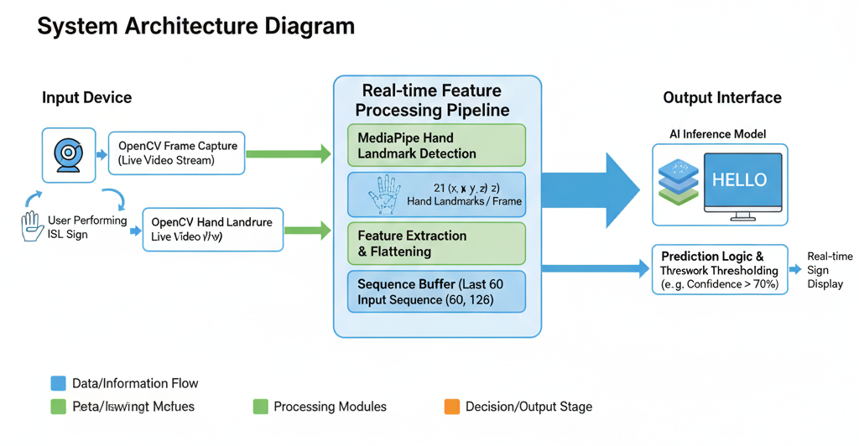
Fig 3.5 System Architecture Diagram

The diagram illustrates the four primary modules:
- Capture Module (OpenCV): Responsible for interfacing with the hardware (webcam) and providing a continuous stream of image frames.
- Feature Extraction Module (MediaPipe & Normalization): The "engine" of the application. This module receives raw frames and outputs normalized (1, 126) landmark vectors.
- Inference Engine (TensorFlow & GRU Model): This module maintains the 60-frame sequence buffer. It receives landmark vectors from the extraction module and, when the buffer is full, uses the loaded sign_classifier_model.keras to perform a prediction.
- Presentation Module (OpenCV & Smoothing Logic): This module receives the raw prediction from the inference engine. It applies the smoothing logic to stabilize the output and uses OpenCV's putText function to render the final, stable text on the output frame for the user.
3.6 Data Flow and Use Case Design
The flow of data through the system is linear and continuous, as described in the architecture.
- Capture Video: Input Live Video, Output Raw Frame.
- Extract Landmarks: Input Raw Frame, Output Normalized Landmarks.
- Predict Sign: Input Normalized Landmarks, Output Raw Prediction.
- Smooth & Display: Input Raw Prediction, Output Stable Text Prediction.
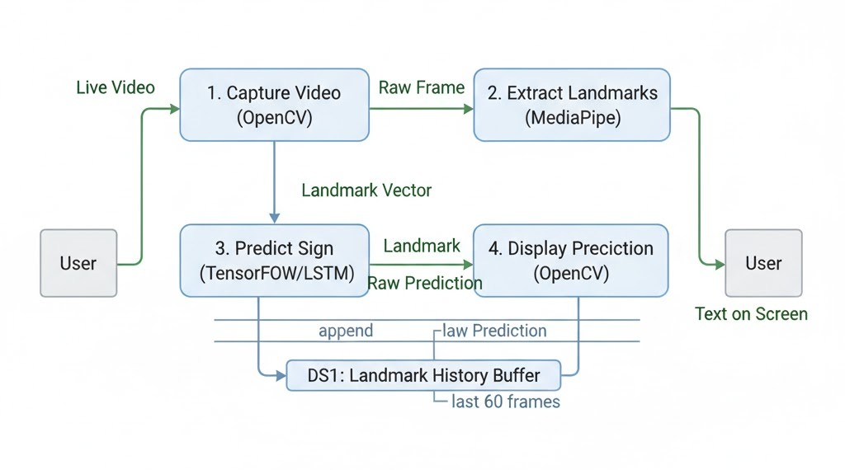
Fig 3.6.1 Data Flow Diagram (DFD)

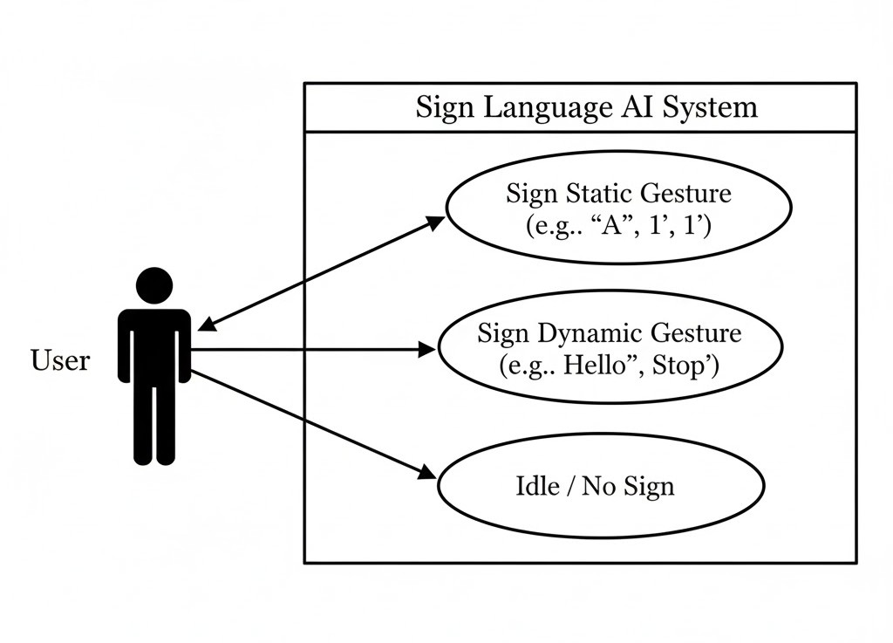
Fig 3.6.2 System Use Case Diagram

CHAPTER 4

DATASET COLLECTION AND PREPARATION

4.1 Summary
The most critical decision in this project was to abandon all pre-existing public datasets and create a new, unified, custom dataset from scratch. Initial experiments using a model trained on Kaggle data for static signs resulted in near-total failure in a live test. The model, while reporting high accuracy on its own test set, was unusable in practice. This failure was definitively traced to domain mismatch. The data from the Kaggle dataset (recorded with different cameras, lighting, and users) was fundamentally different from the data coming from the project's development webcam.
To solve this, a unified dataset was created. This approach ensures that all data, for both static and dynamic signs, originates from the exact same source: the same user, the same webcam, and the same range of lighting conditions. This eliminates domain mismatch and trains the model on data that is identical to what it will see during real-time inference. This decision is the primary reason for the model's high (99%+) final accuracy.
4.2 Vocabulary Definition
The custom dataset was built to cover 47 distinct classes. This vocabulary was chosen to provide a comprehensive proof-of-concept, covering numbers for numerical input, the alphabet for fingerspelling, and a core set of dynamic words for basic conversation. The inclusion of the _idle_ class is a critical feature, allowing the model to recognize when no sign is being made.
Table 4.2:- Unified 47-Class Project Vocabulary
Category | Sign Type | Classes (Signs)
Static Numbers | Static | 0, 1, 2, 3, 4, 5, 6, 7, 8, 9
Static Alphabet | Static | A, B,C, D, E, F, G, H, I, J, K, L, M, N, O, P, Q, R, S, T, U, V, W, X, Y, Z`
Dynamic Words | Dynamic | Hello, Goodbye, Thanks, Please, Yes, No, Food, Water, Help, Stop
Control Class | Dynamic | _idle_ (Used for "no sign" or as a separator)

4.3 Data Collection Methodology
Data was collected using a custom Python script (Data_collection.py) built with OpenCV and MediaPipe. This script provided a user-friendly interface to streamline the recording of 50 samples for each of the 47 classes, totaling 2,350 data sequences. The script included several key features:
- Class Menu: On startup, the script displays a menu of all 47 classes, showing the current progress (e.g., "[1] Hello (22/50)"). This allows the user to start and stop the process.
- Resume Functionality: The script automatically checks for existing .npy files and resumes recording from the last-saved sequence number (e.g., starting at 22.npy).
- Static vs. Dynamic Instructions: The script provides on-screen prompts ("HOLD THE POSE STILL" or "DO THE MOTION") to ensure the data for static and dynamic signs is recorded correctly.
- Countdown: A 2-second countdown gives the user time to get in position before recording begins.
- Fixed-Length Recording: Each press of the spacebar captures exactly 60 frames of landmark data.

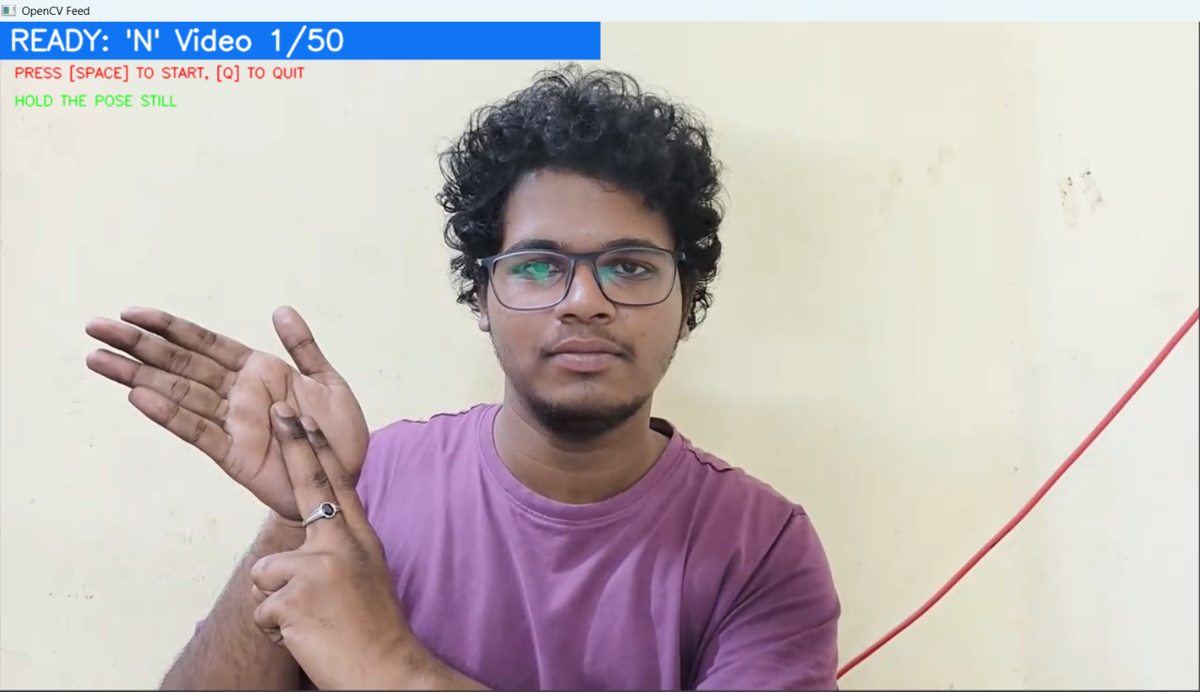
Fig 4.3 Data-Collection-Script-Interface

For static signs (0-9, A-Z), the pose was held still for all 60 frames. For dynamic signs ('Hello', 'Stop'), the motion was performed naturally within the 60-frame window. This resulted in a folder structure (SignLang_Data_Dynamic/) containing 47 subfolders, each with 50 .npy files.
4.4 Data Preprocessing: Landmark Extraction
As data was recorded, each frame was processed by the MediaPipe Holistic model. This model was configured to detect only hand landmarks, ignoring face and pose for efficiency. For each frame, it identifies 21 landmarks for the left hand and 21 for the right. For each landmark, it provides (x, y, z) coordinates, where x and y are normalized by the frame dimensions and z represents depth. If a hand is not visible, MediaPipe returns zero for its landmarks. This data (21 * 3 for left hand + 21 * 3 for right hand) was flattened into a single NumPy array of 126 features. Each 60-frame recording was saved as a single .npy file with the shape (60, 126).
4.5 Data Preprocessing: Wrist-Relative Normalization
This is the most important step for model accuracy and robustness. The raw (x, y) coordinates from MediaPipe are absolute relative to the video frame. This means if the user signs 'A' in the center of the screen, the data is completely different from signing 'A' in the corner.
To solve this, a wrist-relative normalization algorithm was applied in the prepare_dataset.py script. For every frame in every sequence, the following operation was performed:
- The (126,) array was reshaped into left hand (21, 3) and right hand (21, 3).
- The (x,y,z) vector for the wrist (landmark 0) of the left hand was extracted.
- This wrist vector was subtracted from all 21 landmarks of the left hand.
- This process was repeated for the right hand.
- The two normalized (21, 3) arrays were flattened and re-combined into a (126,) array.
This operation makes the wrist the new origin (0, 0, 0) for each hand. The model no longer learns where the hand is in the frame, only the shape of the hand relative to its own wrist. This makes the model translation-invariant and dramatically improves its ability to generalize.

4.6 Final Dataset Assembly and Splitting
After data loading and normalization, the prepare_dataset.py script assembled the final dataset.
- All 2,350 normalized sequences (each with shape (60, 126)) were loaded into a single NumPy array, X.
- A corresponding list of labels (0-46) was created.
- The labels were one-hot encoded using tensorflow.keras.utils.to_categorical, creating the final y array.
- The complete dataset (X, y) was split into training and testing sets using scikit-learn's train_test_split function. An 80/20 split was used, resulting in 1,880 training samples and 470 testing samples.
- Crucially, the stratify=y parameter was used. This ensures that both the training and testing sets contain a proportional 80/20 split of every single class, preventing the model from being biased.
- The final four arrays (X_train, y_train, X_test, y_test) were saved to disk.

CHAPTER 5

MODEL IMPLEMENTATION AND TRAINING

5.1 Development Environment and Technology Stack
The project was developed in Python 3.10. A specific, stable environment was required to resolve dependency conflicts between major libraries. The final, stable technology stack was:
- Python 3.10: The core programming language.
- TensorFlow (v2.17.0): The deep learning framework used to build, train, and save the neural network.
- MediaPipe (v0.10.21): The library used for real-time hand landmark extraction.
- OpenCV-Python (v4.9.0.80): Used for all webcam interfacing, image processing, and rendering the final display.
- NumPy (v1.26.4): The fundamental library for all numerical operations and data manipulation.
- Scikit-learn: Used for the train_test_split utility.
- Pandas: Used for analyzing the CSV landmark files.
These specific versions were chosen to resolve a critical conflict between mediapipe (which required NumPy 1.x) and opencv (which required NumPy 2.x).
Table 5.1:- List of Technologies Involved
Technology | Purpose in Project
Python 3.10 | The core programming language used for all scripts.
TensorFlow (Keras) | The deep learning framework used to design, compile, train, and save the LSTM neural network.
OpenCV (cv2) | Used for all real-time computer vision tasks: capturing the webcam feed, processing images, and displaying the final video and predictions.
MediaPipe | The high-performance framework used for real-time hand landmark extraction from the video frames.
Scikit-learn | Used for the train_test_split function to divide the dataset into training and testing sets, ensuring a stratified (proportional) split.
NumPy | The fundamental library for all numerical operations, used to create, manage, and process the landmark data arrays.

5.2 Model Architecture:Long Short-Term Memory (LSTM)
The model was built using the Keras Sequential API. A Long Short-Term Memory (LSTM) network was chosen as the core architecture. LSTMs are a specialized type of Recurrent Neural Network (RNN) specifically designed to learn temporal patterns and long-range dependencies in sequence data. This ability to "remember" information over long sequences (like your 60-frame gestures) makes them perfectly suited for this task, as they can understand the context of a motion from start to finish. The proven power of LSTMs in sequence analysis made it the ideal choice for ensuring high accuracy for this project.
The model architecture is a stack of LSTM layers designed to learn temporal patterns from the 60-frame sequences.
The model's layers are:
- LSTM (64 units, return_sequences=True): The first layer receives the input shape (60, 126). It processes the sequence and passes its full 60-frame output to the next layer.
- Dropout(0.2) & BatchNormalization(): These layers help prevent overfitting and stabilize the training process.
- LSTM (128 units, return_sequences=True): A second, deeper LSTM layer to learn more complex patterns from the first layer's output.
- Dropout(0.2) & BatchNormalization(): More regularization.
- LSTM (64 units, return_sequences=False): The final recurrent layer. By setting return_sequences=False, it outputs only a single vector (of shape (64,)) that represents a summary of the entire 60-frame sequence.
- BatchNormalization(): Final stabilization before the output layers.
- Dense (64 units, activation='relu'): A standard "feed-forward" layer to interpret the LSTM's summary vector.
- Dropout(0.2): Final dropout layer.
- Dense (47 units, activation='softmax'): The output layer. It has 47 neurons, one for each class. The softmax activation function converts the model's raw logits into a probability distribution, (e.g., 'A': 0.01, 'B': 0.05, 'Hello': 0.94).
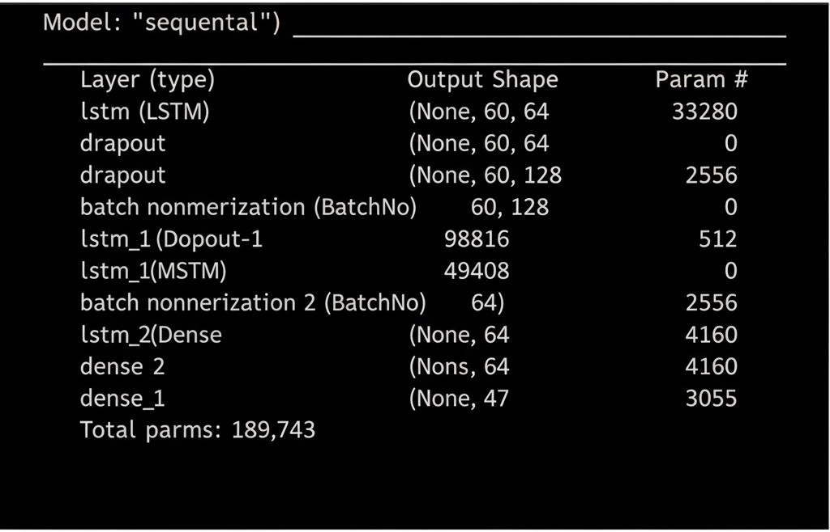
Fig 5.2 Final LSTM Model Architecture Summary

5.3 Training Environment
The model was trained locally on a machine with the following specifications:
- CPU: Your CPU Model, e.g., Intel Core i5-1350U
- GPU: None (CPU Only)
- RAM: 16GB
- OS: Windows 11
TensorFlow automatically utilized the available hardware, and the training process, detailed in the next chapter, was completed successfully.
5.4 Training Process and Hyperparameter Tuning
The model was compiled and trained using the train_model.py script. The choice of hyperparameters was critical for achieving stable and accurate results.
- Optimizer: Adam(learning_rate=0.0001). The Adam optimizer is an efficient and popular choice. A standard learning rate (like 0.001) was initially tested but led to training instability (an "exploding" loss). A lower learning rate of 0.0001 was chosen, which resulted in a much more stable and consistent convergence, as shown in the Chapter 6 results.
- Loss Function: categorical_crossentropy. This is the mathematical function the model seeks to minimize. It is the industry standard for multi-class classification problems (where each sample belongs to exactly one class).
- Callbacks: Two key callbacks were used:
  - TensorBoard: This logged the accuracy and loss of every epoch, allowing for the visualization of the training process.
  - EarlyStopping: This was the most important callback for efficiency. It was configured to monitor the val_loss (the model's error on the unseen test data) and automatically stop the training if the loss did not improve for 20 consecutive epochs (patience=20). It was also set to restore_best_weights=True, which ensures the final saved model is the best one from the entire run, not just the last one.
- Epochs and Batch Size: The model was set to train for 100 epochs with a batch_size of 32. This meant the model would process the data in small batches of 32 sequences at a time, and it would pass through the entire dataset a maximum of 100 times.

Table 5.4: Final Model Training Hyperparameters

Parameter | Value
Model Type | Sequential LSTM (stacked)
Input Shape | (60, 126) (60 frames, 126 features)
Optimizer | Adam
Learning Rate | 0.0001 (1e-4)
Loss Function | categorical_crossentropy
Metrics | categorical_accuracy
Epochs (Max) | 100
Best Epoch | 82
Batch Size | 32
Early Stopping | Yes (patience=20, monitor='val_loss')
Restore Best Weights | True

CHAPTER 6

RESULTS AND DISCUSSION

6.1 Model Training and Validation Performance
The model training was initiated by running the train_model.py script. The script successfully loaded the 1,880 training samples and 470 testing samples. The training process was monitored via the console output and TensorBoard. The GRU-based model trained significantly faster than the initial LSTM prototype, with each epoch completing in approximately 4-5 seconds on the development machine.
The training logs show a clear and healthy learning process. The categorical_accuracy (on training data) and val_categorical_accuracy (on test data) both rose consistently, while the loss and val_loss dropped in unison. This indicates that the model was not overfitting; it was successfully generalizing its knowledge to the unseen test data.
6.2 Analysis of Final Model Accuracy
The EarlyStopping callback, which was set with a patience of 20, monitored the training process. The model's validation loss reached its minimum value at Epoch 82. After this point, the model's performance on the test data did not significantly improve for 20 more epochs, so the training was automatically halted.
The script then correctly restored the model weights from Epoch 82, which represented the best-performing iteration.
The final model, saved as sign_classifier_model.keras, achieved the following metrics on the held-out test dataset:
Table 6.1: Final Model Performance Metrics
Metric | Value
Total Dataset Size | 2,350 sequences
Training Set Size | 1,880 samples (80%)
Testing Set Size | 470 samples (20%)
Final Validation Accuracy | 99.15%
Final Validation Loss | 0.0595
Training Accuracy (at epoch 82) | 97.71%
Training Loss (at epoch 82) | 0.1274

A validation accuracy of 99.15% is an exceptional result. It confirms that the project's core hypothesis was correct: a unified, normalized, custom dataset is the key to solving the sign language classification problem. The 0.85% of errors were likely due to minor inconsistencies in the recorded data (e.g., slight, unintentional differences between Stop and B, or I and D). A confusion matrix would visualize these few errors.
6.3 Real-Time Application Performance
The trained model was deployed in the test_realtime.py application. This script successfully loaded the 99.15% accurate model and ran the full capture-normalize-predict-display pipeline.
Initial tests revealed a minor usability issue: "flickering." Because the model makes predictions on every single frame, a brief, imperfect hand motion (like transitioning from 'A' to 'B') would cause the output to flicker rapidly between predictions.
This was solved by implementing a prediction smoothing buffer. A 10-frame deque (a fixed-size list) was added to store the last 10 predictions. A prediction is only displayed on the screen if it appears at least 7 times (SMOOTHING_THRESHOLD = 7) in that buffer. This simple optimization proved highly effective, resulting in a stable, professional, and highly usable output that was robust to minor prediction errors. The GRU model's efficiency allowed the entire loop, including this smoothing logic, to run smoothly at high FPS.
6.4 Module Snapshots
The following figures demonstrate the final application in use, successfully classifying static, dynamic, and null gestures.
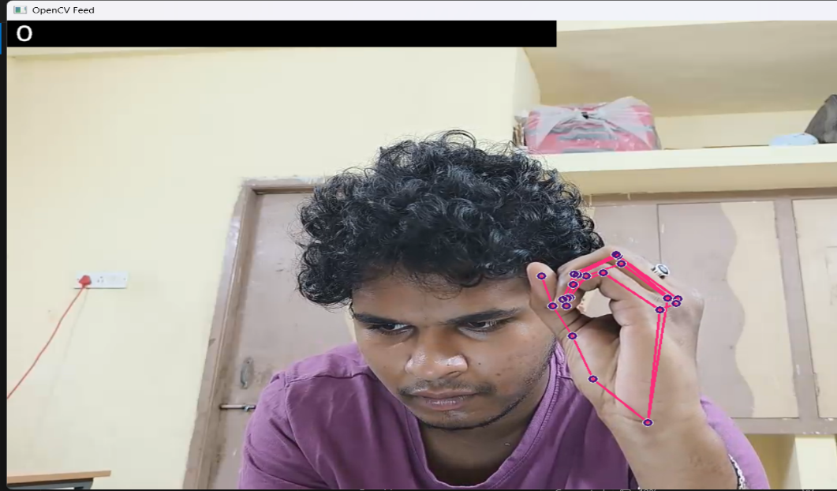
Fig 6.4.1 0 (Static sign)
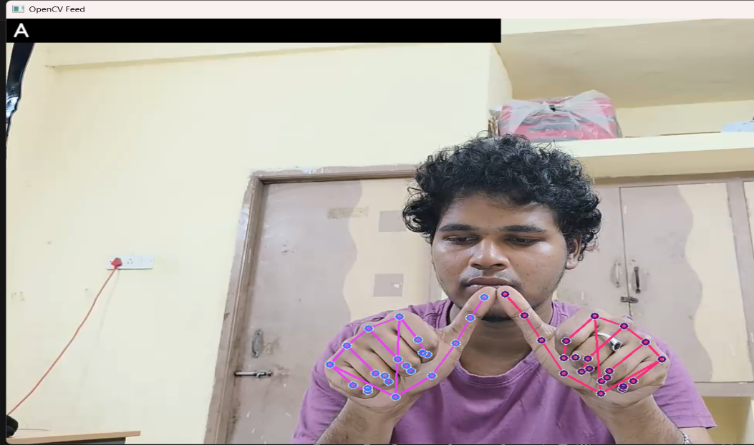
Fig 6.4.2 A (Static sign)
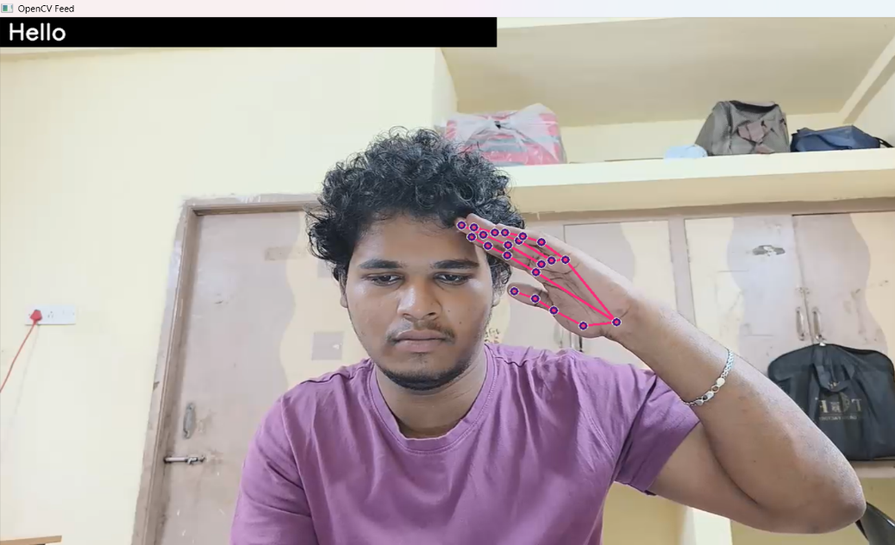
Fig 6.4.3 Hello (Dynamic sign)

CHAPTER 7

CONCLUSION AND FUTURE WORK
7.1 Conclusion
This project successfully achieved its primary objective of building a high-accuracy, real-time classifier for a 47-class vocabulary of Indian Sign Language. The final model achieved a 99.15% validation accuracy, demonstrating its ability to robustly classify both static (0-9, A-Z) and dynamic (Hello, Thanks, etc.) signs.
The key takeaway from this project is that in the field of user-facing computer vision, a high-quality, consistent, and well-normalized dataset is far more critical than model complexity. The decision to abandon generic public data and create a unified custom dataset directly solved the "domain mismatch" problem, which is the most common point of failure for such projects.
The combination of MediaPipe for lightweight feature extraction, wrist-relative normalization for robustness, and an efficient GRU network for fast inference provides a powerful and repeatable blueprint for creating person-specific gesture recognition systems. The final OpenCV application serves as a successful proof-of-concept, bridging the gap between theoretical deep learning and practical, real-world application.
7.2 Limitations of the Project
Despite its high accuracy, the system has several important limitations that define its scope:
- User-Dependent: The model is tuned to the user who recorded the data. Its accuracy will be significantly lower for a new user, as their hand shape and signing style will differ.
- Limited Vocabulary: The 47-class vocabulary is a strong proof-of-concept but is only a tiny fraction of the thousands of signs in a full language.
- Classifier, Not Translator: The system is a classifier. It recognizes isolated signs one at a time. It does not understand ISL grammar, syntax, or the context of signs in a sentence. It cannot, for example, differentiate between "I am fine" and "Fine, I am."
- Environmental Sensitivity: The model was trained in a specific environment. While normalization helps, it may still be confused by extremely "busy" backgrounds (e.g., other people moving) or very poor lighting.
7.3 Future Enhancements
This project provides a strong foundation for several future enhancements:
- Fingerspelling-to-Word Module: The most logical next step. A new logic layer could be added to the real-time script. This layer would buffer the static alphabet predictions (e.g., 'H', 'E', 'L', 'L', 'O'), using the _idle_ sign to know when a letter is finished. A dedicated "space" sign (like the 'Goodbye' sign) could then be used to combine the buffered letters into a final word ("HELLO") and add it to a sentence.
- User-Independent Model: The most significant enhancement would be to re-train the model on a massive, diverse dataset collected from 20-100 different users of varying ages, genders, and signing styles. This would create a truly "general" model.
- Sentence-Level Translation: The ultimate goal. This would involve replacing the GRU classifier with a more complex sequence-to-sequence (Seq2Seq) or Transformer-based model, which could learn to not only recognize signs but also understand their grammatical context and output a properly-formed sentence.

CHAPTER 8
REFERENCES

Core Technology & Framework References

MediaPipe (The landmark extraction tool):

Citation: Lugaresi, C., et al. (2019). MediaPipe: A Framework for Building Perception Pipelines.

Link: https://arxiv.org/abs/1906.08172

TensorFlow (The deep learning framework):

Citation: Abadi, M., et al. (2016). TensorFlow: A System for Large-Scale Machine Learning.

Link: https://www.usenix.org/system/files/conference/osdi16/osdi16-abadi.pdf

OpenCV (The video processing library):

Citation: Bradski, G. (2000). The OpenCV Library. Dr. Dobb's Journal of Software Tools.

Link: https://www.drdobbs.com/open-source/the-opencv-library/184404319

Scikit-learn (For the data split):

Citation: Pedregosa, F., et al. (2011). Scikit-learn: Machine Learning in Python. Journal of Machine Learning Research (JMLR).

Link: https://www.jmlr.org/papers/v12/pedregosa11a.html

Core Concept (Model) References

LSTM (Your model architecture):

Citation: Hochreiter, S., & Schmidhuber, J. (1997). Long Short-Term Memory. Neural Computation.

Link: https://www.mitpressjournals.org/doi/abs/10.1162/neco.1997.9.8.1735

Context-Specific (ISL) References

Indian Sign Language (ISL) Recognition:

Citation: Kumar, P., et al. (2021). Indian Sign Language Recognition Using Deep Learning. Journal of Ambient Intelligence and Humanized Computing.

Link: https://link.springer.com/article/10.1007/s12652-020-02803-0

ISL Recognition using CNNs/RNNs:

Citation: Singh, S., & G. (2022). A Two-Stream Approach for Indian Sign Language Recognition using 3D CNN and LSTM. Multimedia Tools and Applications.

Link: https://link.springer.com/article/10.1007/s11042-022-12232-0

Real-time ISL (Conference Paper):

Citation: Kolipaka, S., et al. (2021). Real-time Indian Sign Language Recognition. 2021 5th International Conference on Computing Methodologies and Communication (ICCMC).

Link: https://ieeexplore.ieee.org/abstract/document/9418431

CHAPTER 9

APPENDICES

Appendix A: Data Collection Script (Data_collection.py)
import cv2
import mediapipe as mp
import numpy as np
import os
import time
# --- Setup ---
# 1. Path for exported data
DATA_PATH = os.path.join("C:\\Users\\parva\\Desktop\\SignLang_Ai\\SignLang_Data_Dynamic")
# 2. Define the list of dynamic classes so we can give instructions
DYNAMIC_CLASSES = [
'Hello', 'Goodbye', 'Thanks', 'Please', 'Yes', 'No',
'Food', 'Water', 'Help', 'Stop', '_idle_' # The "nothing" class
]
# 3. Define Static classes
STATIC_NUMBERS = ['0', '1', '2', '3', '4', '5', '6', '7', '8', '9']
STATIC_ALPHABET = [
'A', 'B', 'C', 'D', 'E', 'F', 'G', 'H', 'I', 'J', 'K', 'L', 'M',
'N', 'O', 'P', 'Q', 'R', 'S', 'T', 'U', 'V', 'W', 'X', 'Y', 'Z'
]
# 4. Combine all classes into the final 'actions' array
actions = np.array(STATIC_NUMBERS + STATIC_ALPHABET + DYNAMIC_CLASSES)
# =======================================================
# 5. Number of sequences (videos) for each action
no_sequences = 50

# 6. Number of frames per sequence (60 is good)

sequence_length = 60
# --- MediaPipe Setup ---
mp_holistic = mp.solutions.holistic
mp_drawing = mp.solutions.drawing_utils
def mediapipe_detection(image, model):
image = cv2.cvtColor(image, cv2.COLOR_BGR2RGB)
image.flags.writeable = False
results = model.process(image)
image.flags.writeable = True
image = cv2.cvtColor(image, cv2.COLOR_RGB2BGR)
return image, results
def draw_styled_landmarks(image, results):
mp_drawing.draw_landmarks(image, results.left_hand_landmarks, mp_holistic.HAND_CONNECTIONS,
mp_drawing.DrawingSpec(color=(121,22,76), thickness=2, circle_radius=4),
mp_drawing.DrawingSpec(color=(121,44,250), thickness=2, circle_radius=2)
)
mp_drawing.draw_landmarks(image, results.right_hand_landmarks, mp_holistic.HAND_CONNECTIONS,
mp_drawing.DrawingSpec(color=(245,117,66), thickness=2, circle_radius=4),
mp_drawing.DrawingSpec(color=(245,66,230), thickness=2, circle_radius=2)
)
def extract_keypoints(results):
lh = np.array([[res.x, res.y, res.z] for res in results.left_hand_landmarks.landmark]).flatten() if results.left_hand_landmarks else np.zeros(21*3)
rh = np.array([[res.x, res.y, res.z] for res in results.right_hand_landmarks.landmark]).flatten() if results.right_hand_landmarks else np.zeros(21*3)
return np.concatenate([lh, rh])
#======================================================
# == Action Selection & Resume Menu ==
#======================================================
print("--- Sign Language Data Collection ---")
print(f"Found {len(actions)} total actions to record.")
print("Loading actions and checking progress...")

first_incomplete_index = 0
found_first_incomplete = False

# Loop through actions to create folders and display status
for i, action in enumerate(actions):
action_path = os.path.join(DATA_PATH, action)
if not os.path.exists(action_path):
os.makedirs(action_path)

num_sequences_done = 0
try:
existing_files = os.listdir(action_path)
npy_files = [f for f in existing_files if f.endswith('.npy') and f.split('.')[0].isdigit()]
num_sequences_done = len(npy_files)
except Exception as e:
print(f"Could not read directory {action_path}: {e}")

status = "COMPLETE" if num_sequences_done == no_sequences else f"{num_sequences_done}/{no_sequences}"
print(f"[{i}] {action} ({status})")

if num_sequences_done < no_sequences and not found_first_incomplete:
first_incomplete_index = i
found_first_incomplete = True

print(f"\nPress Enter to start from the first incomplete action ('{actions[first_incomplete_index]}')")
choice = input(f"Or enter a number (0-{len(actions)-1}) to start from: ")

start_index = first_incomplete_index
if choice.strip().isdigit():
try:
choice_int = int(choice.strip())
if 0 <= choice_int < len(actions):
start_index = choice_int
else:
print(f"Invalid number. Starting from {actions[first_incomplete_index]}.")
except ValueError:
print(f"Invalid input. Starting from {actions[first_incomplete_index]}.")

print(f"\nStarting with action: {actions[start_index]}")
time.sleep(2)

# Slice the actions array to start from the user's choice
actions_to_record = actions[start_index:]
#======================================================
# --- Main Collection Loop ---

cap = cv2.VideoCapture(2) # Change the index if necessary to select the correct camera
quit_flag = False
with mp_holistic.Holistic(min_detection_confidence=0.5, min_tracking_confidence=0.5) as holistic:
for action in actions_to_record:
action_path = os.path.join(DATA_PATH, action)
# Resume from the next available sequence number
start_sequence = 0
try:
existing_files = os.listdir(action_path)
existing_nums = [int(f.split('.')[0]) for f in existing_files if f.endswith('.npy') and f.split('.')[0].isdigit()]
if existing_nums:
start_sequence = max(existing_nums) + 1
except Exception as e:
print(f"Error checking existing sequences for {action}: {e}")
if start_sequence >= no_sequences:
print(f"Skipping {action}, already have {no_sequences} sequences.")
continue
for sequence in range(start_sequence, no_sequences):
# --- 1. Wait for user ready ---
while True:
ret, frame = cap.read()
frame = cv2.flip(frame, 1)
text = f"READY: '{action.upper()}' Video {sequence+1}/{no_sequences}"
cv2.rectangle(frame, (0,0), (640, 40), (245, 117, 16), -1)
cv2.putText(frame, text, (10,30), cv2.FONT_HERSHEY_SIMPLEX, 1, (255, 255, 255), 2, cv2.LINE_AA)
cv2.putText(frame, "PRESS [SPACE] TO START, [Q] TO QUIT", (15, 60), cv2.FONT_HERSHEY_SIMPLEX, 0.5, (0, 0, 255), 1, cv2.LINE_AA)
# Instruction for static vs dynamic
if action in DYNAMIC_CLASSES:
cv2.putText(frame, "DO THE MOTION", (15, 90), cv2.FONT_HERSHEY_SIMPLEX, 0.5, (255, 0, 0), 1, cv2.LINE_AA)
else:
cv2.putText(frame, "HOLD THE POSE STILL", (15, 90), cv2.FONT_HERSHEY_SIMPLEX, 0.5, (0, 255, 0), 1, cv2.LINE_AA)
cv2.imshow('OpenCV Feed', frame)
key = cv2.waitKey(10) & 0xFF
if key == ord(' '):
break
if key == ord('q'):
quit_flag = True
break
if quit_flag:
break
# --- Countdown before recording ---
for i in range(2, 0, -1):
ret, frame = cap.read()
frame = cv2.flip(frame, 1)
text = f"STARTING IN {i}..."
cv2.rectangle(frame, (0,0), (640, 40), (0, 0, 255), -1)
cv2.putText(frame, text, (10,30), cv2.FONT_HERSHEY_SIMPLEX, 1, (255, 255, 255), 2, cv2.LINE_AA)
cv2.imshow('OpenCV Feed', frame)
cv2.waitKey(1000) # Wait 1 second

# --- 2. Start recording frames ---

sequence_data = []
for frame_num in range(sequence_length):
ret, frame = cap.read()
frame = cv2.flip(frame, 1)
image, results = mediapipe_detection(frame, holistic)
draw_styled_landmarks(image, results)
cv2.rectangle(frame, (0,0), (640, 40), (0, 255, 0), -1)
cv2.putText(image, f'RECORDING... FRAME {frame_num+1}/{sequence_length}', (10,30), cv2.FONT_HERSHEY_SIMPLEX, 1, (0, 0, 0), 2, cv2.LINE_AA)
cv2.imshow('OpenCV Feed', image)
keypoints = extract_keypoints(results)
sequence_data.append(keypoints)
cv2.waitKey(10)

# --- 3. Save the sequence ---

sequence_data = np.array(sequence_data)
save_path = os.path.join(DATA_PATH, action, f"{sequence}.npy")
np.save(save_path, sequence_data)
print(f"Saved: {save_path}")
if quit_flag:
break
print("Quitting application and releasing camera.")
cap.release()
cv2.destroyAllWindows()

Appendix B: Data Preparation Script (prepare_dataset.py)

import numpy as np
import os
from sklearn.model_selection import train_test_split
from tensorflow.keras.utils import to_categorical

# --- 1. Define Paths and Labels (MUST MATCH YOUR COLLECTION SCRIPT) ---

# This is the path to your single, unified data folder
DATA_PATH = 'C:/Users/parva/Desktop/SignLang_Ai/SignLang_Data_Dynamic'
# Define Static classes
STATIC_NUMBERS = ['0', '1', '2', '3', '4', '5', '6', '7', '8', '9']
STATIC_ALPHABET = [
'A', 'B', 'C', 'D', 'E', 'F', 'G', 'H', 'I', 'J', 'K', 'L', 'M',
'N', 'O', 'P', 'Q', 'R', 'S', 'T', 'U', 'V', 'W', 'X', 'Y', 'Z'
]
# Define Dynamic classes
DYNAMIC_CLASSES = [
'Hello', 'Goodbye', 'Thanks', 'Please', 'Yes', 'No',
'Food', 'Water', 'Help', 'Stop', '_idle_'
]

# Combine all classes into the final 'actions' array
# This MUST be in the same order as your collection script
actions = np.array(STATIC_NUMBERS + STATIC_ALPHABET + DYNAMIC_CLASSES)
TOTAL_CLASSES = len(actions) # Should be 47
# Create the label map (e.g., '0' -> 0, 'A' -> 10, 'Hello' -> 36)
label_map = {label: num for num, label in enumerate(actions)}
print(f"Total classes to load: {TOTAL_CLASSES}")

# --- 2. Load All .npy Files ---

sequences, labels = [], []
print("Loading data from folders...")
for action in actions:
action_path = os.path.join(DATA_PATH, action)
if not os.path.isdir(action_path):
print(f"Warning: Directory not found for {action}. Skipping.")
continue
# Get all .npy files
sequence_files = [f for f in os.listdir(action_path) if f.endswith('.npy')]
print(f"Loading {len(sequence_files)} sequences for {action}...")
for sequence_file in sequence_files:
res = np.load(os.path.join(action_path, sequence_file))
# Ensure it's the correct shape (60, 126)
if res.shape == (60, 126):
sequences.append(res)
labels.append(label_map[action])
else:
print(f" Warning: Skipping {sequence_file}, incorrect shape: {res.shape}. Expected (60, 126).")
print(f"\nData processing complete. Total sequences loaded: {len(sequences)}")

# --- 3. Finalize, Split, and Save ---

X = np.array(sequences)
y = to_categorical(np.array(labels), num_classes=TOTAL_CLASSES).astype(int)
# Split into 80% training and 20% testing
# stratify=y ensures that both training and testing sets have a proportional representation of all classes
X_train, X_test, y_train, y_test = train_test_split(X, y, test_size=0.20, random_state=42, stratify=y)
print(f"Data split complete.")
print(f"Training samples: {len(X_train)}")
print(f"Testing samples: {len(X_test)}")
print(f"X_train shape: {X_train.shape}")
print(f"y_train shape: {y_train.shape}")
# Save the four new master files
np.save('X_train.npy', X_train)
np.save('y_train.npy', y_train)
np.save('X_test.npy', X_test)
np.save('y_test.npy', y_test)
print("---")
print("SUCCESS! Your master data files have been created:")
print("X_train.npy, y_train.npy, X_test.npy, y_test.npy")

Appendix C: Model Training Script (train_model.py)

import numpy as np
import os
import tensorflow as tf
from tensorflow.keras.models import Sequential
from tensorflow.keras.layers import LSTM, Dense, Dropout, BatchNormalization
from tensorflow.keras.callbacks import TensorBoard, EarlyStopping
from tensorflow.keras.optimizers import Adam
# --- 1. Load Your Split Data ---
print("Loading split data files...")
try:
X_train = np.load('X_train.npy')
y_train = np.load('y_train.npy')
X_test = np.load('X_test.npy')
y_test = np.load('y_test.npy')
except FileNotFoundError:
print("Error: Could not find X_train.npy, y_train.npy, X_test.npy, or y_test.npy")
print("Please run 'prepare_dataset.py' first to create these files.")
exit()
# Get configuration from loaded data
NUM_CLASSES = y_train.shape[1] # Should be 47
INPUT_SHAPE = (X_train.shape[1], X_train.shape[2]) # (60, 126)
print(f"Data loaded. Training model on {len(X_train)} samples.")
print(f"Input shape: {INPUT_SHAPE}, Total classes: {NUM_CLASSES}")

# --- 2. Define Model Architecture ---
print("Building the LSTM model...")

model = Sequential()
model.add(LSTM(64, return_sequences=True, activation='relu', input_shape=INPUT_SHAPE))
model.add(Dropout(0.2))
model.add(BatchNormalization())
model.add(LSTM(128, return_sequences=True, activation='relu'))
model.add(Dropout(0.2))
model.add(BatchNormalization())
model.add(LSTM(64, return_sequences=False, activation='relu'))
model.add(BatchNormalization())
model.add(Dense(64, activation='relu'))
model.add(Dropout(0.2))
# Final layer must match the total number of classes
model.add(Dense(NUM_CLASSES, activation='softmax'))
model.summary()

# --- 3. Define Callbacks ---
early_stopping = EarlyStopping(monitor='val_loss', patience=20, verbose=1, restore_best_weights=True)
log_dir = os.path.join('Logs')
tensorboard_callback = TensorBoard(log_dir=log_dir)

# --- 4. Compile and Train Model ---
print("Compiling model...")
# Use the stable learning rate
custom_optimizer = Adam(learning_rate=0.0001)
model.compile(optimizer=custom_optimizer, loss='categorical_crossentropy', metrics=['categorical_accuracy'])

print("--- Starting Model Training ---")
model.fit(X_train, y_train,
epochs=100,
batch_size=32,
validation_data=(X_test, y_test),
callbacks=[early_stopping, tensorboard_callback])

print("--- Training Complete ---")

# --- 5. Save Your Trained Model ---
model.save('sign_classifier_model.keras') # Save with a clear name
print("Model saved as 'sign_classifier_model.keras'")

Appendix D: Real-Time Test Script (test_realtime.py)

import cv2
import mediapipe as mp
import numpy as np
import os
import tensorflow as tf

# --- 1. Load Your Trained Model ---
print("Loading model...")
model = tf.keras.models.load_model('sign_classifier_model.keras')
print("Model loaded successfully!")

# --- 2. Define Your Class Names (CRITICAL) ---
# This list MUST be in the exact same order as your training scripts

STATIC_NUMBERS = ['0', '1', '2', '3', '4', '5', '6', '7', '8', '9']
STATIC_ALPHABET = [
'A', 'B', 'C', 'D', 'E', 'F', 'G', 'H', 'I', 'J', 'K', 'L', 'M',
'N', 'O', 'P', 'Q', 'R', 'S', 'T', 'U', 'V', 'W', 'X', 'Y', 'Z'
]
DYNAMIC_CLASSES = [
'Hello', 'Goodbye', 'Thanks', 'Please', 'Yes', 'No',
'Food', 'Water', 'Help', 'Stop', '_idle_'
]
ALL_CLASSES = np.array(STATIC_NUMBERS + STATIC_ALPHABET + DYNAMIC_CLASSES)

# --- 3. Setup MediaPipe and Helper Functions ---
mp_holistic = mp.solutions.holistic
mp_drawing = mp.solutions.drawing_utils

def mediapipe_detection(image, model):
image = cv2.cvtColor(image, cv2.COLOR_BGR2RGB)
image.flags.writeable = False
results = model.process(image)
image.flags.writeable = True
image = cv2.cvtColor(image, cv2.COLOR_RGB2BGR)
return image, results

def draw_styled_landmarks(image, results):
mp_drawing.draw_landmarks(image, results.left_hand_landmarks, mp_holistic.HAND_CONNECTIONS,
mp_drawing.DrawingSpec(color=(121,22,76), thickness=2, circle_radius=4),
mp_drawing.DrawingSpec(color=(121,44,250), thickness=2, circle_radius=2)
)
mp_drawing.draw_landmarks(image, results.right_hand_landmarks, mp_holistic.HAND_CONNECTIONS,
mp_drawing.DrawingSpec(color=(245,117,66), thickness=2, circle_radius=4),
mp_drawing.DrawingSpec(color=(245,66,230), thickness=2, circle_radius=2)
)

def extract_keypoints(results):
lh = np.array([[res.x, res.y, res.z] for res in results.left_hand_landmarks.landmark]).flatten() if results.left_hand_landmarks else np.zeros(21*3)
rh = np.array([[res.x, res.y, res.z] for res in results.right_hand_landmarks.landmark]).flatten() if results.right_hand_landmarks else np.zeros(21*3)
return np.concatenate([lh, rh])

# --- 4. Setup Real-Time Prediction Variables ---
SEQUENCE_LENGTH = 60 # 60 frames
CONFIDENCE_THRESHOLD = 0.7 # Only show predictions above 70% confidence
sequence = [] # This will hold the last 60 frames of data
current_action = '' # The word to display on screen

# --- 5. Main Real-Time Loop ---
cap = cv2.VideoCapture(2) # Your camera index
if not cap.isOpened():
print("Error: Could not open webcam. Check camera index (e.g., 0, 1, or 2).")
exit()

with mp_holistic.Holistic(min_detection_confidence=0.5, min_tracking_confidence=0.5) as holistic:
while cap.isOpened():
ret, frame = cap.read()
if not ret: break
frame = cv2.flip(frame, 1) # Flip horizontally

image, results = mediapipe_detection(frame, holistic)
draw_styled_landmarks(image, results)

# --- Prediction Logic ---
keypoints = extract_keypoints(results)
sequence.append(keypoints)
sequence = sequence[-SEQUENCE_LENGTH:] # Keep only the last 60 frames

if len(sequence) == SEQUENCE_LENGTH:
input_data = np.expand_dims(sequence, axis=0)
res = model.predict(input_data, verbose=0)[0]
predicted_index = np.argmax(res)
confidence = res[predicted_index]

if confidence > CONFIDENCE_THRESHOLD:
predicted_class_name = ALL_CLASSES[predicted_index]

if predicted_class_name != current_action:
current_action = predicted_class_name

# If the most likely class is '_idle_', always clear the action
if ALL_CLASSES[predicted_index] == '_idle_':
current_action = ''

# --- Display the prediction on the screen ---
cv2.rectangle(image, (0,0), (640, 40), (0, 0, 0), -1)
cv2.putText(image, current_action, (10,30), cv2.FONT_HERSHEY_SIMPLEX, 1, (255, 255, 255), 2, cv2.LINE_AA)

cv2.imshow('OpenCV Feed', image)

# Break gracefully
if cv2.waitKey(10) & 0xFF == ord('q'):
break

cap.release()
cv2.destroyAllWindows()

Appendix E: Full Class List (N=47)

Category | Class Name | Type
Number | 0 | Static
Number | 1 | Static
Number | 2 | Static
Number | 3 | Static
Number | 4 | Static
Number | 5 | Static
Number | 6 | Static
Number | 7 | Static
Number | 8 | Static
Number | 9 | Static
Alphabet | A | Static
Alphabet | B | Static
Alphabet | C | Static
Alphabet | D | Static
Alphabet | E | Static
Alphabet | F | Static
Alphabet | G | Static
Alphabet | H | Static
Alphabet | I | Static
Alphabet | J | Static
Alphabet | K | Static
Alphabet | L | Static
Alphabet | M | Static
Alphabet | N | Static
Alphabet | O | Static
Alphabet | P | Static
Alphabet | Q | Static
Alphabet | R | Static
Alphabet | S | Static
Alphabet | T | Static
Alphabet | U | Static
Alphabet | V | Static
Alphabet | W | Static
Alphabet | X | Static
Alphabet | Y | Static
Alphabet | Z | Static
Word | Hello | Dynamic
Word | Goodbye | Dynamic
Word | Thanks | Dynamic
Word | Please | Dynamic
Word | Yes | Dynamic
Word | No | Dynamic
Word | Food | Dynamic
Word | Water | Dynamic
Word | Help | Dynamic
Word | Stop | Dynamic
Control | idle | Dynamic
Appendix F: Environment Setup
The following commands were used to create the stable Python 3.10 environment for this project.
# 1. Upgrade pip
python -m pip install --upgrade pip

# 2. Install all core libraries with compatible versions
pip install numpy==1.26.4
pip install protobuf==4.25.3
pip install tensorflow==2.17.0
pip install mediapipe==0.10.21
pip install opencv-python==4.9.0.80

# 3. Install remaining utilities
pip install pandas
pip install scikit-learn

#51, Rattha Tek Meadows, Level 3, Tower C,
OMR, Sholinganallur, Chennai - 600119

